**PRACTICAL – 4**

**AIM:**

|  |
| --- |
| **Convert the below given C Program into Assembly Language.**  **main()**  **{**  **Int l, n, o, p;**  **l = m + n + o + p;**  **}** |

**CODE:**

ORG 100H

MOV BL,05H

MOV CL,04H

MOV DL,02H

MOV AH,05H

ADD BL,CL

SUB BL,DL

ADD BL,AH

MOV AL,BL

RET

**OUTPUT:**

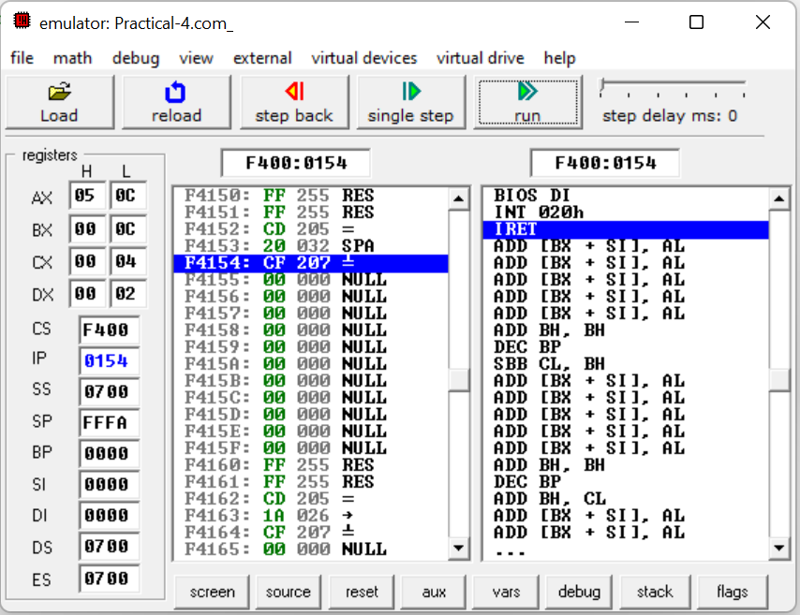

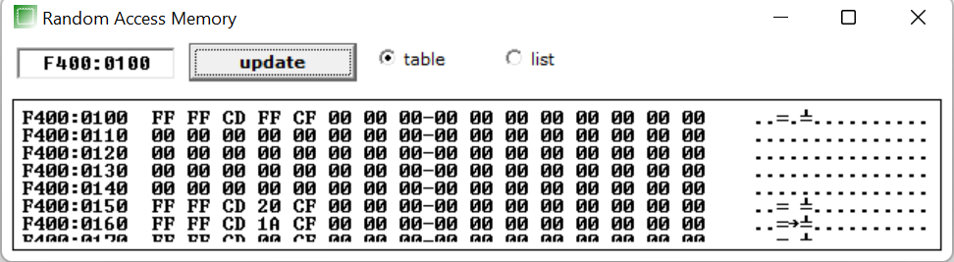

**CONCLUSION:** In this practical we learnt how to convert a C program into assembly language and learnt use of ADD and SUB.